
Universidad Nacional Autónoma de México

Escuela Nacional Preparatoria Plantel 6 “Antonio Caso”

Science Fiction Texts

Answer document
English V Unit 6

Student’s name:
Class:

English V Unit 6
Prediction is very difficult, especially if it’s about the future
(Niels Bohr)

Topic: Written text: Science fiction texts

Objective - Along these activities you'll:
- read a science fiction story,
- identify elements or characteristics that science fiction texts share.

Write your answers in the blue rectangles.

- Before you read
 1. Activating Prior Knowledge

Answer the questions:

1.1 Writing
- Do you have a favorite science fiction short story or novel?
- Which one?
- List three science fiction elements from your selected title.

You can find information about science fiction by clicking on the link: 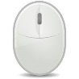https://www.dictionary.com/e/what-is-science-fiction-sci-fi/

 Did you know that...?
 1.1.1 Reading
Read the Science fiction definition by Encyclopedia Britannica to know or reinforce your knowledge about the topic.

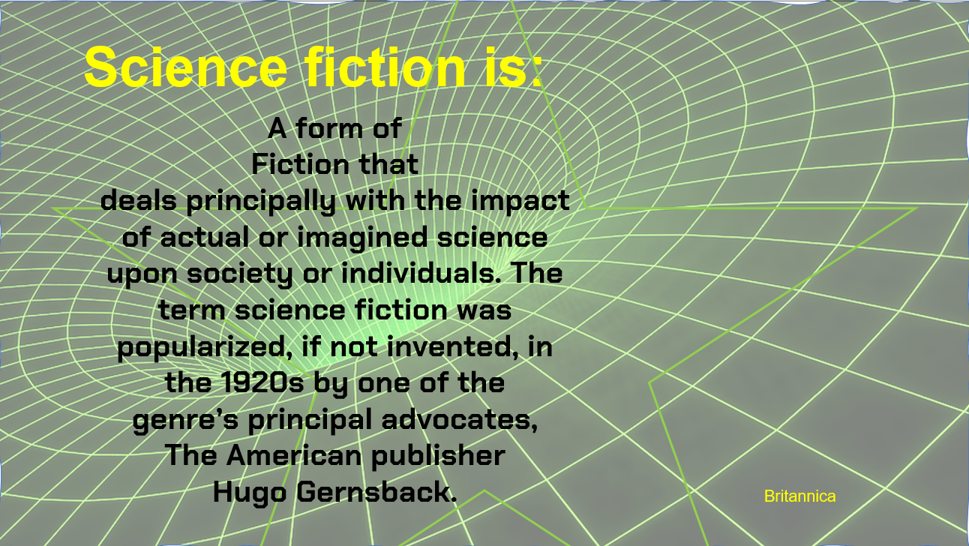

Wormhole Space Time - Free image on Pixabay

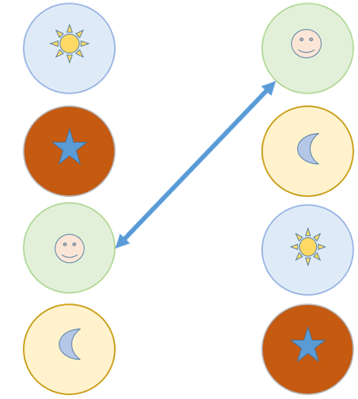 1.2 Matching
Look at the title of two science fiction stories. Write the numbers of the images that correspond to each title.
The fun they had (Isaac Asimov) All summer in a day (Ray Bradbury)

1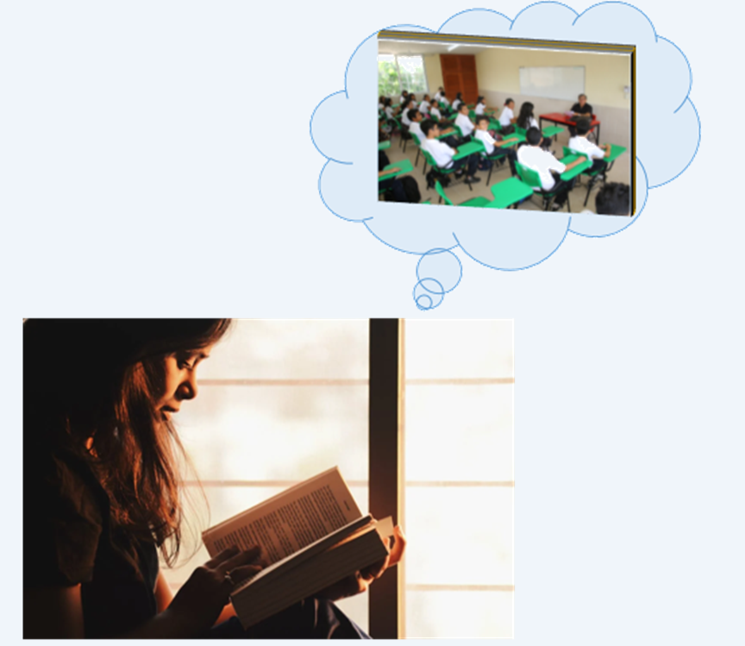 2 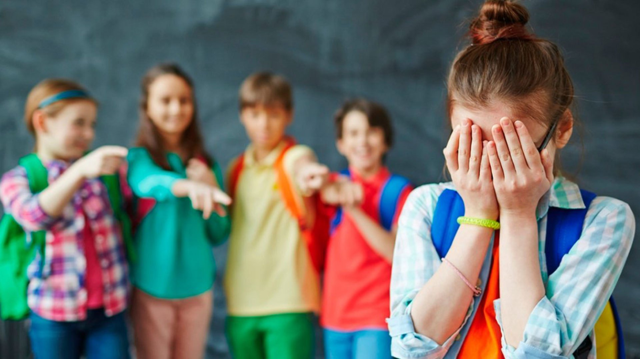

3 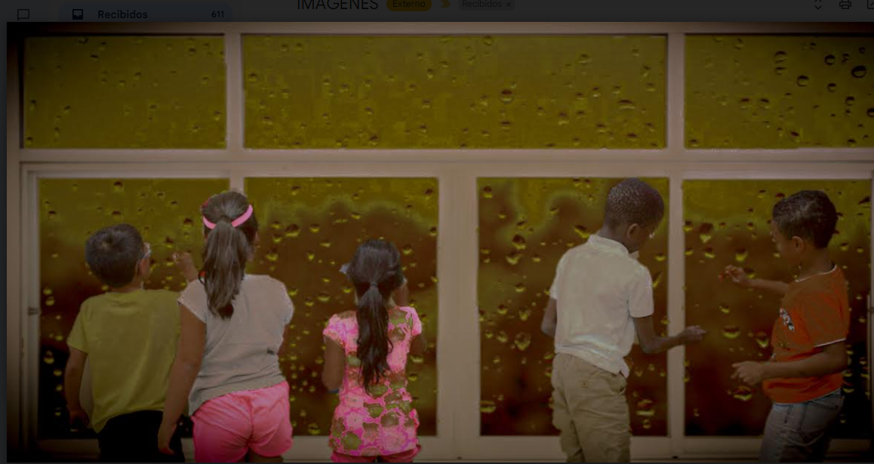 4 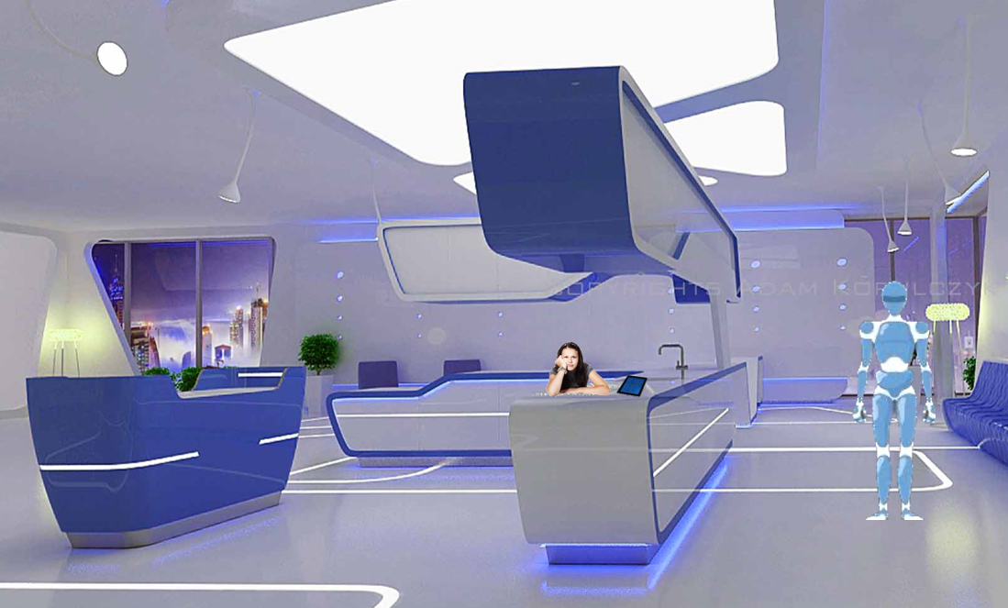

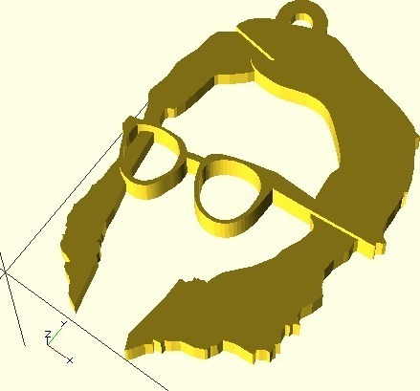 1.3 About the author
1.3.1 Writing
Write 3 biographical facts about Isaac Asimov and his literary work. Click on the links to find information about him.
https://www.britannica.com/biography/Isaac-Asimov
https://en.wikipedia.org/wiki/Isaac_Asimov

1.4 Video

Watch the interview - Isaac Asimov: Does Science Fiction Predict the Future? 2020. https://youtu.be/f3kqqQSvLxQ You can turn the subtitles on if you wish!

Then, select the best option: T - True or F - False

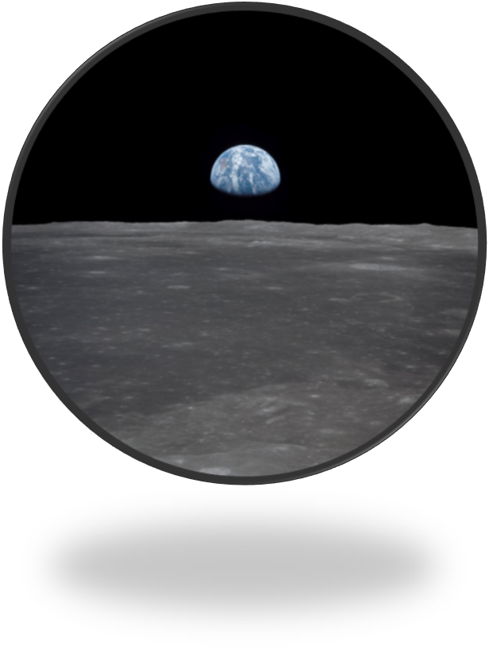
Apollo 11 approaches the moon. Flickr. https://www.flickr.com/photos/nasamarshall/48325286662

Statements | T | F
- In 1939 Asimov described the first flight around the moon and back, which happened in 1968
- The first flight around the moon and back happened in 1974
- Asimov describes mixed feelings about his prediction of the first flight around the moon and back: pleased and upset
- All future events Asimov describes in his books have really come true
- According to Asimov, predicting the future doesn’t involve a lot of work

- While you read
You can read the whole short story to get a general idea or read it as you answer the activities
http://web1.nbed.nb.ca/sites/ASD-S/1820/J%20Johnston/Isaac%20Asimov%20-%20The%20fun%20they%20had.pdf

2.1 Reading
Read the epigraph and the first part of the story


2.2 Vocabulary
Along the story “The fun they had” you’ll find six vocabulary activities related to this story (2.2.1-2.2.6).
Choose the correct answer to each question

The Fun they had
He smiled at her and
gave her an apple, then
took the teacher apart.

by Isaac Asimov

2.2.1 Vocabulary
Choose the correct option according to the text:
‘When you’re through with the book, you just throw it away…’
you’re through means:
to have finished
to no longer be in a relationship with someone
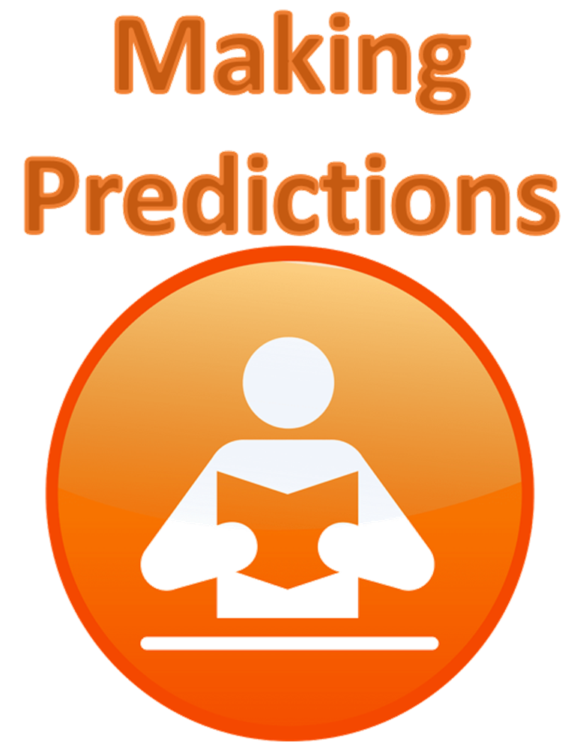 2.3 Predicting
How will Margie react to the fact that the book is about school? Write a short prediction:



2.2.2 Vocabulary
Choose the correct option:
‘Margie was scornful’
scornful means:
showing or feeling disdain
showing or feeling delight

2.2.3 Vocabulary
Choose the correct option:
‘She always had to write them out in a punch code…’
punch code means:
a computing language, which machines can easily understand
a code in a card
2.4 Writing
Answer the next four questions
Below you can review the definition of the literary elements related to these questions

- What kind of world (setting) is portrayed in the story?
- Who is narrating the story?
- Who are the characters in the story?
- What’s the author’s intention with the story? (To warn about something, have fun, compare, etc.) (purpose)

Some short story elements:
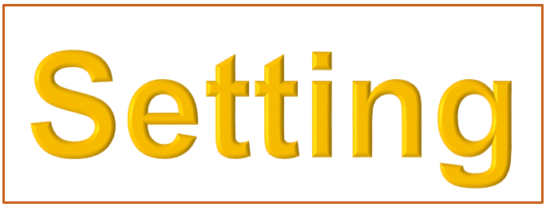
Point of view is the vantage point from which the story is told. The person telling the story is the narrator. In first-person point of view, the narrator is a character in the story. In third-person point of view, the narrator is outside the story. | Setting is the time and place of the story’s action. Setting can also include customs, values, and beliefs of a place or an era.

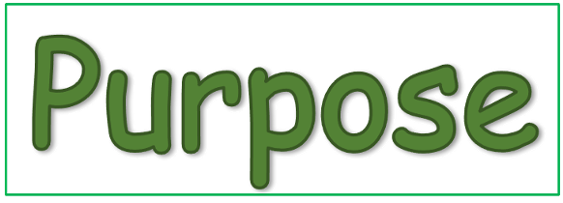

Characters are the actors in the story. They can be people, animals, robots, or whatever the writer chooses. The main character is called the protagonist. | A writer usually has a purpose or goal for a piece of writing. Most writing has one of these purposes  - to entertain readers  - to inform readers about something  - to persuade readers of something

2.5 Writing
List two examples from “The fun they had”, that you consider are characteristics of science fiction texts

 2.6 Understanding
What is the main conflict in the story?
Select an option!

You can read the definition of conflict below

- The relationship between the County Inspector and Margie
- The relationship between Margie and her mother
- Technological progress which lacks human connection, represented by the mechanical teacher, and Margie

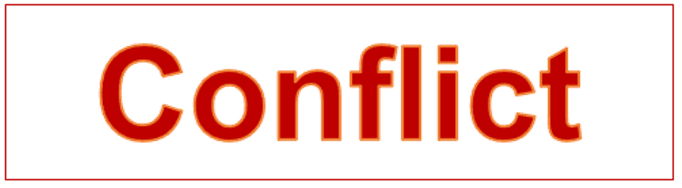
Conflict is the central struggle between opposing forces in a story or play. An external conflict is the struggle of a character against an outside force. An internal conflict exists within the mind of a character.

2.7 Writing
List two examples from this story that you think are characteristics of science fiction texts

2.2.4 Vocabulary
Choose the correct option:
‘.. the history sector had blanked out completely.’
blank out means:
to try not to think about something, forget it
to suddenly become empty

2.2.5 Vocabulary
Choose the correct option:
‘He added loftily, pronouncing the word carefully, Centuries ago’.
loftily means:
having or showing low estimate of one’s own importance
in an arrogant, condescendingly, superior way

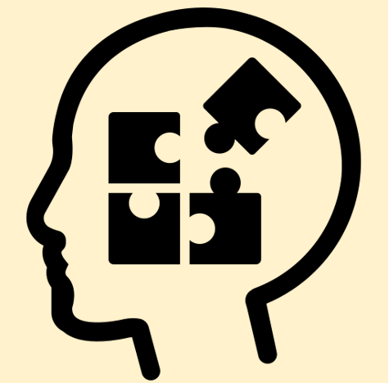 2.8 Reflecting and writing

Relate some events in the story to your own experience:

- Write four ideas about online school during the pandemic and face to face school
- What similarities (2) and differences (2) can you find between your situation and the situation described in the story?

2.9 Writing
Do you prefer face to face or online school? Explain briefly

2.2.6 Vocabulary
Choose the correct option:
‘“Maybe” he said nonchalantly.’
nonchalantly means:
worried, troubled or anxious
in a casually calm and relaxed manner

2.10 Reflecting
Do you think Margie was curious about old school, or she didn’t care about it?

2.11 Making Predictions
Predict the end of the story in 3-4 ideas.

III. After you read

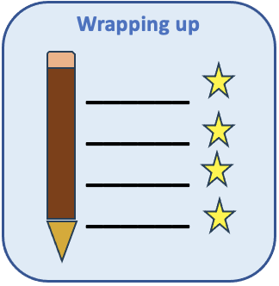 3.1 Wrapping up

 Explain briefly if your predictions were similar to the end of the story:

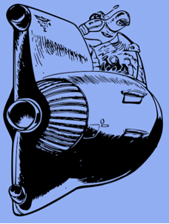 3.2 Characteristics of Science fiction texts

In the next list you’ll find common characteristics that science fiction novels or short stories include. Tick the ones you found in “The fun they had”
Science fiction texts: characteristics | ✔
Time travel
Mind control, telepathy, and telekinesis
Aliens, extraterrestrial lifeforms, and mutants
Space travel and exploration
Fictional or futuristic worlds
Superintelligent computers and robots
Scientific progress
Critical commentary about current or future society
Imaginative possibilities of life and technology
Teleportation
Parallel universes
Interplanetary warfare

3.3 Reflecting
What does Asimov criticize in this story? Read the ideas below. Tick the ones that reflect the author’s criticism

Technological progress in education leads to lack of social development
Social experience at school is necessary for learners
Technological advances facilitate access to information, but deprive students from social exchange
Mechanical teachers are unable to make decisions to solve learning problems

 3.4 Organizing your ideas
Create a mind map about the story. Include:
Setting
Characters
Point of view
Conflict
Purpose (theme)

You can add more short story elements if you wish!

3.5 Reflecting and writing
What did you learn after reading the story? Your ideas are important!

Self assessment
Tick in the second column the activities you have successfully completed and understood, or tick in the right column, the ones you haven’t fully understood and need to improve. You may try to answer the ones you need to master!

Activity | Successfully completed | Improvement needed
1.1 Writing (activating previous knowledge)
1.2 Matching (images to short story titles)
1.3.1 Writing (about the author)
1.4 Video (questions about the interview with Asimov)
2.2.1-2.2.6 (6 questions to get the meaning of words-vocabulary)
2.3 Predicting Margie’s reaction towards the old book
2.4 Writing (answering questions about setting, point of view, characters, purpose)
2.5 Two examples of science fiction characteristics in “The fun they had”
2.6 Understanding the main conflict in the story
2.7 Writing two more examples of science fiction characteristics this story
2.8 Reflecting and writing about your personal experience during the pandemic and similarities and differences between your situation and the one if the short story
2.9 Writing about your own preferences between face to face and online school
2.10 Reflecting about Margie’s interest in old school or not
2.11 and 3.1 Predicting the end of the story and confirming predictions
3.2 Identifying characteristics of science fiction texts
3.3. Identifying Asimov criticism in this story
3.4 Organizing your ideas in a mind map
3.5 Reflecting and writing: what did you learn after reading this story?

References
Asimov, I. (1951). The Fun they Had. [versión electrónica]. http://web1.nbed.nb.ca/sites/ASD-S/1820/J%20Johnston/Isaac%20Asimov%20-%20The%20fun%20they%20had.pdf
Gregersen, E. (2023). Isaac Asimov. Encyclopaedia Britannica [version electrónica]. Encyclopaedia Britannica Inc. https://www.britannica.com/biography/Isaac-Asimov
Isaac Asimov. En Wikipedia: https://en.wikipedia.org/wiki/Isaac_Asimov
Lex Clips. (2020, 26 Ene). Does Science Fiction Predict the Future? [video]. Lexclps. https://youtu.be/f3kqqQSvLxQ
McGraw-Hill. (2000). Glencoe Literature - The Reader’s Choice Course 1. McGraw-Hill.
Sterling, B. et al. (2023). Science Fiction. En Encyclopaedia Britannica [version electrónica]. Encyclopaedia Britannica Inc. https://www.britannica.com/search?query=science+fiction

Botones e imágenes
Adjieargoputra. (s.f.) Icon icon. [imagen]. Creazilla. Icon icon. Free download transparent .PNG | Creazilla
Altmann, G. (s.f). Feedback. [imagen]. Public Domain Pictures. Feedback Free Stock Photo - Public Domain Pictures
Axelle. B. (s.f.) La lluvia en la ventana. [fotografía]. Public Domain Pictures. La lluvia en la ventana Stock de Foto gratis - Public Domain Pictures
Clker-Free-Vector-Images. (s.f.). Button No Yes Free Photo. [fotografía]. Nedpix.com. Button,yes,no,red,green - free image from needpix.com
Clker-Free-Vector-Images. (s.f). Check Mark Check Ok royalty-free vector graphic. [imagen]. Pixabay.com. Check Mark Ok - Free vector graphic on Pixabay
Creazilla. (s.f). Couple is Questioning clipart. [imagen]. Creazilla [Couple is Questioning clipart. Free download transparent .PNG | Creazilla

Creazilla. (s.f.). Read orange icon. [imagen]. Creazilla.com. Free download transparent .PNG | Creazilla

English/English. (2016,). Video Cámara Película. [imagen]. Pixabay. Video Cámara Película - Gráficos vectoriales gratis en Pixabay - Pixabay
Flat icons. (s.f.). Mind map - Free icon. [imagen]. Flaticon.com. Mind map - Free education icons
Fundación Bancaja. (2017). Aula de Artes. Escuela de Verano. [fotografía]. Flickr. Fundación Bancaja organiza Aula de Artes. Escuela de verano

Hassan, M. (s.f.). Brain Storming Illustration. [imagen]. Stockvault.net. Free Stock Photo by mohamed hassan on Stockvault.net
JohnsonMartin. (2015). Wormhole Space Time. [imagen]. Pixabay. Wormhole Space Time - Free image on Pixabay

Kainz, C. (2011). Gadgets. [fotografía]. Flickr. Gadgets | Apple iPad, Apple iPhone 4, Sony PSG-505 eBook Rea… | Flickr

Korulczyk, A. (2012). Projekt wnętrz biura KLD. [imagen]. Wikimedia Commons. File:Adam Korulczyk - projekt wnętrz biura KLD.jpg -

Krakensawa. (2004). Alumnos2. [fotografía]. Wikimedia commons. https://commons.wikimedia.org/wiki/File:Alumnos2.jpg

LoveYouAll. (s.f.). List icon [imagen]. Creazilla.com. Free download transparent .PNG | Creazilla
Metamaquina. (s.f.). Isaac Asimov. keychain 3D Model. (imagen].Creazilla. Isaac Asimov keychain 3d model. Free download. | Creazilla
National Aeronautics and Space Agency. (2019). Apollo 11 Approaches the Moon [fotografía]. Flickr. Apollo 11 Approaches the Moon | This view from the Apollo 11… | Flickr

Open Clipart. (s.f.). Vocabulary. [imagen]. Free Svg.org. Vocabulary | Free SVG
Peters, D. (2013). Book-icon-orange. [imagen]. Wikimedia Commons. File:Book-icon-orange.png - Wikimedia Commons

PickPik. (s.f.). Woman with face in right hand. [fotografía]. PickPik.com. Royalty-Free photo: Woman with face on right hand | PickPik

Pixabay. (s.f.). Thumbs Up, Emoji Smiley. [imagen]. Pixabay.com. Thumbs Up Emoji Smiley - Free vector graphic on Pixabay
Pyfisch. (s.f.). WV in review icon. [imagen]. Creazilla.com. WV in review icon. Free download transparent .PNG | Creazilla
Rawpixel. (s.f.). Rocket collage element, black & white illustration psd. [imagen]. Rawpixel.com. Rocket collage element, black & white illustration psd. Free public domain CC0 image.
Shah, R. (2018). Mujer Leyendo Un Libro Junto a La Ventana. [fotografía]. Pexels. https://www.pexels.com/es-es/foto/mujer-leyendo-un-libro-junto-a-la-ventana-1031588/
Sixsixfive. (2015). Mouse Icon. [imagen]. Openclipart.com. Mouse Icon - Openclipart
Stöckel, A. (s.f). Cosmos, espacio exterior, estrella. [fotografía]. PublicDomainPictures.com. Cosmos, espacio exterior, estrella.
Uddin, A.. (2020). Noun Planning. [imagen]. 1325509. Wikimedia Commons. File:Noun Planning 1325509.svg - Wikimedia Commons
Vania Barbara. (2022). Acoso-escolar-barcelona-Bullying. [fotografía]. Wikimedia Commons. https://commons.wikimedia.org/wiki/File:Acoso-escolar-barcelona-Bullying.jpg
VectorPortal. (s.f.). Stock Robot Vector Clip Art. [imagen]. VectorPortal. https://vectorportal.com/es/vector/robot-vector-clip-art/19044
VideoPlasty. (2018). Book with Lens Flat Icon Vector. [imagen]. Wikimedia Commons CC-BY-SA 4.0. https://upload.wikimedia.org/wikipedia/commons/5/5f/Book_with_Lens_Flat_Icon_Vector.svg
Aviso legal
D.R. © 2022. Universidad Nacional Autónoma de México. Excepto donde se indique lo contrario, esta obra está bajo una licencia Creative Commons Atribución-No comercial 4.0 Internacional (CC BY-NC 4.0 Internacional).

https://creativecommons.org/licenses/by-nc/4.0/legalcode.es
Forma sugerida de citar el recurso
Valenzuela, S. M. (2024). Science Fiction Texts. [Recurso Educativo Digital] Escuela Nacional Preparatoria, Plantel 6 “Antonio Caso” UNAM.
Con la licencia  usted es libre de:
- Compartir: copiar y redistribuir el material en cualquier medio o formato.
- Adaptar: remezclar, transformar y construir a partir del material.
Bajo los siguientes términos:
- Atribución: usted debe dar crédito de manera adecuada, brindar un enlace a la licencia, e indicar si se han realizado cambios. Puede hacerlo en cualquier forma razonable, pero no de forma tal que sugiera que usted o su uso tienen el apoyo de la licenciante.
- No comercial usted no puede hacer uso del material con propósitos comerciales. En los casos que sea usada la presente obra, deben respetarse los términos especificados en esta licencia.

En los casos que sea usada la presente obra, deben respetarse los términos especificados en esta licencia.

